**Number Systems Used In Computers**

Complete the following table:

|  |  |  |  |
| --- | --- | --- | --- |
| **Number System** | **Number Base** | **Digits Used** | **Purpose** |
| Decimal | Base 10 | 0 to 9 | Used for communicating with human users |
| Binary |  |  |  |
| Octal |  |  |  |
| Hexadecimal |  |  |  |

**Decimal vs. Binary System**

Write down the definition of a **Bit** in computer terminology:

Complete the following table:

|  |  |  |
| --- | --- | --- |
|  | **Decimal System** | **Binary System** |
| Uses Digits |  |  |
| Addition Examples |  |  |
| Powers of 10 |  |  |
| Evaluate 111 |  |  |

**Powers of 2**

|  |  |  |  |  |
| --- | --- | --- | --- | --- |
| **Power  of 2** | **Decimal Value** | **Integer Range** | **Number  of Bits** | **Computer Binary** |
| 21 | 2 | 0 - 1 | 1 | 0001 |
| 22 | 4 | 0 - 3 | 2 | 0011 |
| 23 |  |  |  | 0111 |
| 24 |  |  |  | 1111 |
| 25 |  |  |  | 0001 1111 |
| 26 |  |  |  | 0011 1111 |
| 27 |  |  |  | 0111 1111 |
| 28 | 256 | 0 - 255 | 8 | 1111 1111 |
| 29 |  |  |  | 0001 1111 1111 |
| 210 |  |  |  | 0011 1111 1111 |
| 211 |  |  |  | 0111 1111 1111 |
| 212 |  |  |  | 1111 1111 1111 |
| 213 |  |  |  | 0001 1111 1111 1111 |
| 214 |  |  |  | 0011 1111 1111 1111 |
| 215 |  |  |  | 0111 1111 1111 1111 |
| 216 | 65,536 | 0 – 65,535 | 16 | 1111 1111 1111 1111 |

**Conversions**

Convert the following binary numbers to decimal:

11 binary =

101 binary =

1010 binary =

Convert the following decimal numbers to binary:

6 decimal =

13 decimal =

**Binary Addition**

Add the following binary numbers. (verify your answers using decimal)

|  |  |  |  |  |  |  |  |  |  |  |  |  |  |
| --- | --- | --- | --- | --- | --- | --- | --- | --- | --- | --- | --- | --- | --- |
| |  |  | | --- | --- | | **0101** | **(decimal 5)** | | **+ 0010** | **(decimal 2)** | |  |  | | |  |  | | --- | --- | | **0101** | **(decimal 5)** | | **+ 1010** | **(decimal 10)** | |  |  | |
| |  |  | | --- | --- | | **0011** | **(decimal 3)** | | **+ 0010** | **(decimal 2)** | |  |  | | |  |  | | --- | --- | | **0110** | **(decimal 6)** | | **+ 0011** | **(decimal 3)** | |  |  | |

**Prefixes**

* Kilo (K) means __________________ Multiply by x______________
* Mega (M) means _________________ Multiply by x______________

* Giga (G) means __________________ Multiply by x______________
* Tera (T) means __________________ Multiply by x______________

**Examples**

1. 64 Kbps (Kilo-bits per seconds) = ___________________ bps (bits per second)
2. 256 Giga-bytes = _________________________________ bytes
3. 256 Giga-bytes = _________________________________ bits

**Computer Memory Structures**

|  |  |  |  |
| --- | --- | --- | --- |
| **Structure** | **Number of Bits** | **Largest Value** | **Used For...** |
| Bit |  |  |  |
| Byte |  |  |  |
| Word |  |  |  |
| Short Integer |  |  |  |
| Double Word |  |  |  |
| Long Integer |  |  |  |
| Memory Address |  |  |  |

**Memory Organization**

Bit (Binary Digit)

* One bit can have a value of ________ or _________
* Or a Boolean logic value of ________ or _________

|  |  |  |  |  |  |  |  |  |  |  |  |  |  |  |  |  |  |  |  |
| --- | --- | --- | --- | --- | --- | --- | --- | --- | --- | --- | --- | --- | --- | --- | --- | --- | --- | --- | --- |
| |  |  |  |  | | --- | --- | --- | --- | | 0 | 0 | 0 | 0 | | |  |  |  |  | | --- | --- | --- | --- | | 0 | 0 | 0 | 0 | | |  |  |  |  | | --- | --- | --- | --- | | 0 | 0 | 0 | 0 | | |  |  |  |  | | --- | --- | --- | --- | | 0 | 0 | 0 | 0 | |

Byte (8 bits)

* One byte has a size of ________ bits
* A byte has an unsigned integer value range from 0 to _________

|  |  |  |  |  |  |  |  |  |  |  |  |  |  |  |  |  |  |  |  |
| --- | --- | --- | --- | --- | --- | --- | --- | --- | --- | --- | --- | --- | --- | --- | --- | --- | --- | --- | --- |
| |  |  |  |  | | --- | --- | --- | --- | | 0 | 0 | 0 | 0 | | |  |  |  |  | | --- | --- | --- | --- | | 0 | 0 | 0 | 0 | | |  |  |  |  | | --- | --- | --- | --- | | 0 | 0 | 0 | 0 | | |  |  |  |  | | --- | --- | --- | --- | | 0 | 0 | 0 | 0 | |

Word (2 bytes or 16 bits)

* One word has a size of ________ bits
* One word has a size of ________ bytes
* A byte has an unsigned integer value range from 0 to _________

|  |  |  |  |  |  |  |  |  |  |  |  |  |  |  |  |  |  |  |  |
| --- | --- | --- | --- | --- | --- | --- | --- | --- | --- | --- | --- | --- | --- | --- | --- | --- | --- | --- | --- |
| |  |  |  |  | | --- | --- | --- | --- | | 0 | 0 | 0 | 0 | | |  |  |  |  | | --- | --- | --- | --- | | 0 | 0 | 0 | 0 | | |  |  |  |  | | --- | --- | --- | --- | | 0 | 0 | 0 | 0 | | |  |  |  |  | | --- | --- | --- | --- | | 0 | 0 | 0 | 0 | |
|  | |  | |

Long or Double Word (4 bytes or 32 bits)

* One Long word has a size of ________ words
* A Long word has an unsigned integer value range from 0 to _________

|  |  |  |  |  |  |  |  |  |  |  |  |  |  |  |  |  |  |  |  |
| --- | --- | --- | --- | --- | --- | --- | --- | --- | --- | --- | --- | --- | --- | --- | --- | --- | --- | --- | --- |
| |  |  |  |  | | --- | --- | --- | --- | | 0 | 0 | 0 | 0 | | |  |  |  |  | | --- | --- | --- | --- | | 0 | 0 | 0 | 0 | | |  |  |  |  | | --- | --- | --- | --- | | 0 | 0 | 0 | 0 | | |  |  |  |  | | --- | --- | --- | --- | | 0 | 0 | 0 | 0 | |
|  | |  | |
| |  |  |  |  | | --- | --- | --- | --- | | 0 | 0 | 0 | 0 | | |  |  |  |  | | --- | --- | --- | --- | | 0 | 0 | 0 | 0 | | |  |  |  |  | | --- | --- | --- | --- | | 0 | 0 | 0 | 0 | | |  |  |  |  | | --- | --- | --- | --- | | 0 | 0 | 0 | 0 | |
|  | |  | |

**Questions**

1. What is the smallest memory object that can represent a character of information?
   1. Think… How many upper case letters in the alphabet (A to Z)?26
   2. Think… How many lower case letters in the alphabet (a to z)?26
   3. Think… How many number digits (0 to 9)?10
   4. Think… How many punctuation marks?14
   5. Add them all up76
2. Research the ASCII characters set. What is it and how is it related to computer memory?

Every character on the keyboard has its equal binary value. The decimal equal to that binary value is called ASCII (American standard code for information interchange) value. Say for example equal binary value to character 'A' is 01000001, the decimal equal to which is 64.

1. How are strings of characters (Google “String”) represented in computer memory?

Characters are normally represented as strings of seven bits each in an encoding called ASCII (American Standard Code for Information Interchange).

How are negative integers represented in computer memory? (Include a diagram)

The C standard doesn't mandate any particular way of representing negative signed numbers. In most implementations that you are likely to encounter, negative signed integers are stored in what is called two's complement. ... The one's complement of an N-bit number x is defined as x with all its bits flipped, basically.

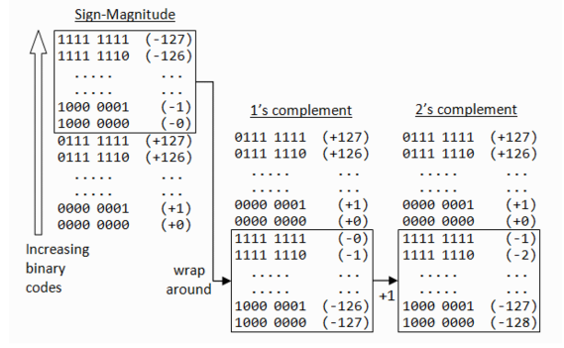

1. How are decimal numbers (Google “Floating Point”) represented in computer memory? (Include a diagram)

The computer memory is organized into strings of bits called words of same length. Decimal numbers are first converted into their binary equivalents and then are represented in either integer or floating point form. Here in an extra zero to the left of the binary number is appended to indicate that it is positive.

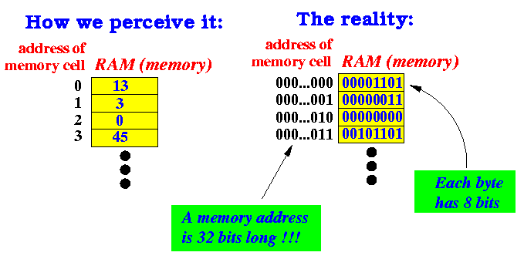

1. A Pixel is computer memory structure used to store image information. How is a Pixel represented in memory? (Include a diagram).

Pixels are the smallest individual element in an image, holding antiquated values that represent the brightness of a given color at any specific point. Typically, the pixels are stored in computer memory as a raster image or raster map, a two-dimensional array of small integers.